Git Commands

What is Git command
# Source: AI Source: Provided by: [Data Path: Persons Table -> ID Column: 1, Name_En Column: Motasem Essam] -> From: [ChatGPT] on [2/16/2026]
A Git command is basically an instruction you give to Git to perform a specific action in your version control workflow. Git commands let you manage your code, track changes, collaborate with others, and organize your project history.
Think of Git as a tool, and the commands are how you tell it what to do.

Categories of Git Commands
# Source: AI Source: Provided by: [Data Path: Persons Table -> ID Column: 1, Name_En Column: Motasem Essam] -> From: [ChatGPT] on [2/16/2026]
- Setup / Configuration
  - Example:
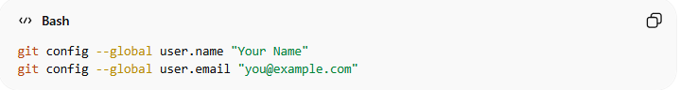
git config --global user.name "Your Name"
git config --global user.email "you@example.com"
  - Sets up your identity for commits.
- Starting a Repository
  - Example:
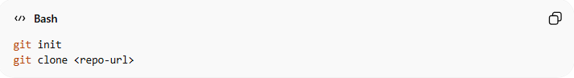
git init
git clone <repo-url>
  - init creates a new Git repo; clone copies an existing repo.
- Tracking Changes
  - Example:
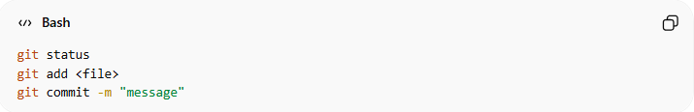
git status
git add <file>
git commit -m "message"
  - Checks changes, stages them, and saves them locally.
- Branching & Merging
  - Example:
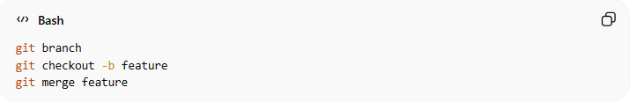
git branch
git checkout -b feature
git merge feature
  - Helps manage multiple versions of your project.
- Sharing / Collaboration
  - Example:
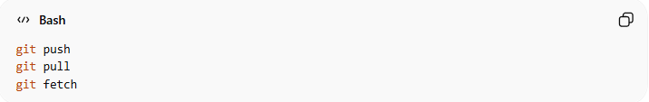
git push
git pull
git fetch
  - Pushes your commits to a remote repo, or brings others’ changes into your local repo.
- Undoing / History
  - Example:
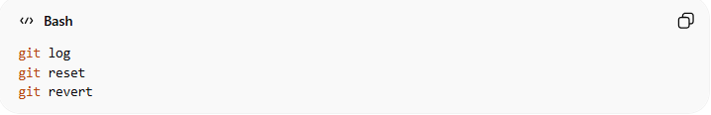
git log
git reset
git revert
  - Lets you check history or undo mistakes safely.

💡 Simple Analogy:
# Source: AI Source: Provided by: [Data Path: Persons Table -> ID Column: 1, Name_En Column: Motasem Essam] -> From: [ChatGPT] on [2/16/2026]
- Git is like a smart notebook for your project.
- Git commands are the instructions telling the notebook what to do: save, branch, share, or undo changes.

